CyberSource is a web application that can be used to view, create and share cybersecurity incidents to benefit the community. Its main purpose is to build a repository of cybersecurity incidents that can be used by the public to understand and help better defend against attacks.

To do this each incident is created with some standardised data and an attackflow diagram that helps users better understand how an attacker might undertake such an attack. By understanding the mind of an attacker it will help user more easily defend against such attacks.

**Contents**

**Users** 3

**Incident Creation** 4

**Part 1 – Uploading an Incident** 4

**Part 2 – Generating Standardised Data** 5

**Part 3 – Diagram Generation** 6

## **Users**

Within CyberSource there are three types of users.

**Reader:** The reader is the default user and what a person is allocated when signing up to the system. A reader can only read incidents.

**Editor:** The editor can do everything a reader can do but they can also create incidents. They upload an incident document, generate some standardised data and then use this to create a diagram of the attack.

**Approver:** An approver can do everything the editor can do but they are the only ones able to approve incidents. By approving an incident it means that they are then able to be shared with all users.

## **Incident Creation**

The process of creating an incident has three parts.

### **Part 1 – Uploading an Incident**

When you create an incident you will first have to upload the incident document and input a few basic bits of information.

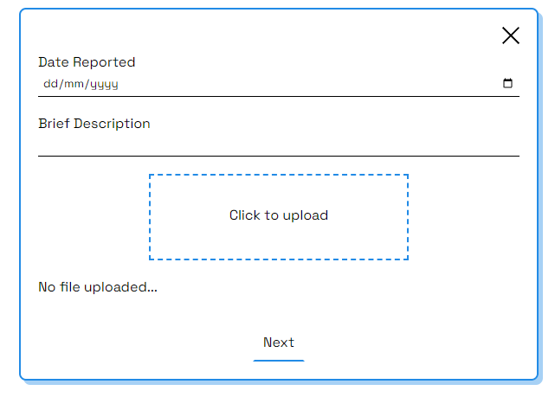

### **Part 2 – Generating Standardised Data**

After hitting ‘Next’ in part 1 the system will attempt to automatically generate some data. The user can then review and edit as needed.

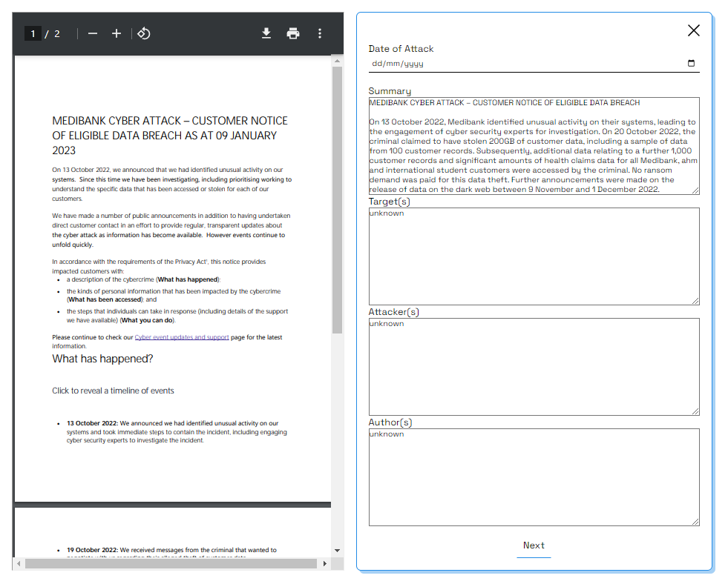

### **Part 3 – Diagram Generation**

After completing part 2 the system will attempt to generate a diagram of the attackflow for the user.

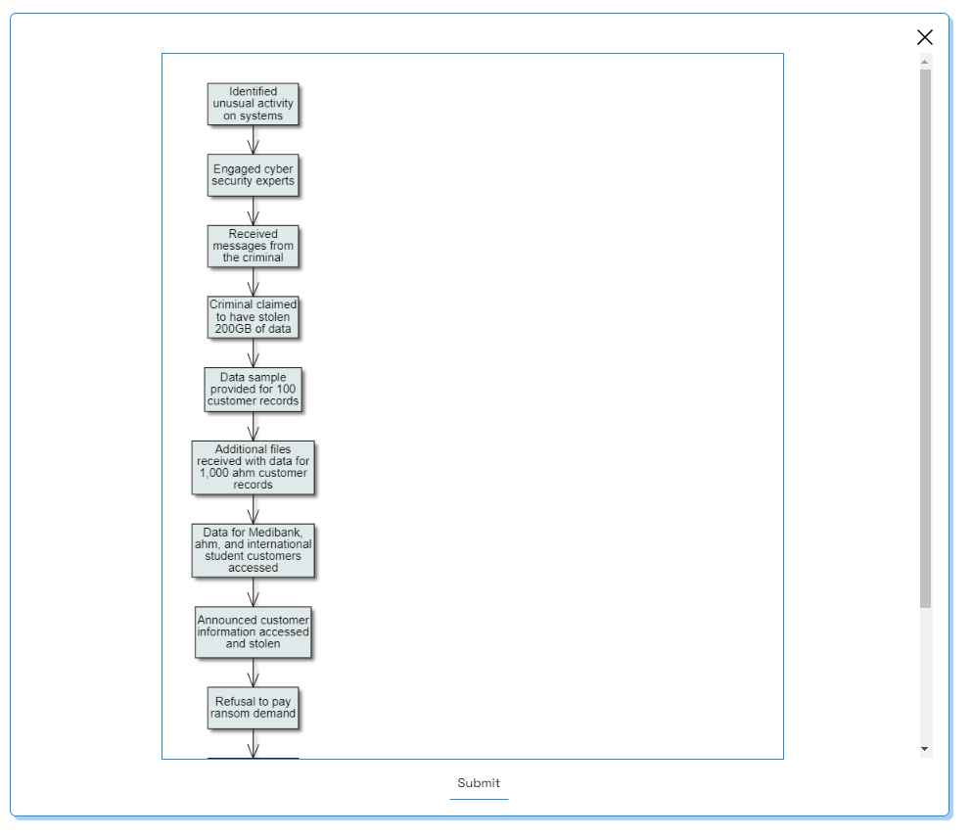

After clicking ‘Submit’ the incident has been created but will not be shared with other users till it is approved.

## **Incident Approval**

A newly created incident needs to be approved before it can be shared with other users. The approver can navigate to the ‘Your Incidents’ tab to see incidents awaiting approval and approve them.

## **Viewing an Incident**

An incident can be viewed by clicking on the corresponding row.

You can toggle between previous versions by using the option at the top.

A user with the editor or approver roles can use the edit current version option to edit the current version. They can then submit this for approval and once approved it will be added for all users to see.